Preparation of Papers in Two-Column Format for Conference Proceedings Sponsored by IEEE

J. Q. Author
IEEE Conference Publishing
445 Hoes Lane
Piscataway, NJ 08854 USA

Abstract-These instructions give you basic guidelines for preparing papers for conference proceedings.
I. Introduction
Your goal is to simulate the usual appearance of papers in an IEEE conference proceedings. For items not addressed in these instructions, please refer to the last issue of your conference’s proceedings or your Publications chair.
Preparing your Electronic Paper
Prepare your paper in full-size format, on US letter paper (8 ½ by 11 inches). For A4 paper, use the A4 settings.
Type Sizes and Typefaces: Follow the type sizes specified in Table I. As an aid in gauging type size, 1 point is about 0.35 mm. The size of the lowercase letter “j” will give the point size. Times New Roman is the preferred font.
1) US Letter Margins: top = 0.75 inches, bottom = 1 inch, side = 0.625 inches. Each column measures 3.5 inches wide, with a 0.25-inch measurement between columns.
2) A4 Margins: top = 19mm, bottom = 43mm, side = 15 mm. The A4 column width is 88mm (3.45 in). The space between the two columns is 4mm (0.17 in). Paragraph indentation is 3.5 mm (0.14 in).
Left- and right-justify your columns. Use tables and figures to adjust column length. On the last page of your paper, adjust the lengths of the columns so that they are equal. Use automatic hyphenation and check spelling. Digitize or paste down figures.
TABLE I
Type Sizes For Papers
Type size (pts.) | Appearance
Type size (pts.) | Regular | Bold | Italic
6 | Table captions,ª table superscripts
8 | Section titles,ª references, tables, table names,ª first letters in table captions, ª figure captions, footnotes, text subscripts, and superscripts
9 |  | Abstract
10 | Authors’ affiliations, main text, equations, first letters in section titles ª |  | Subheading
11 | Authors’ names
24 | Paper title
 | ª Uppercase

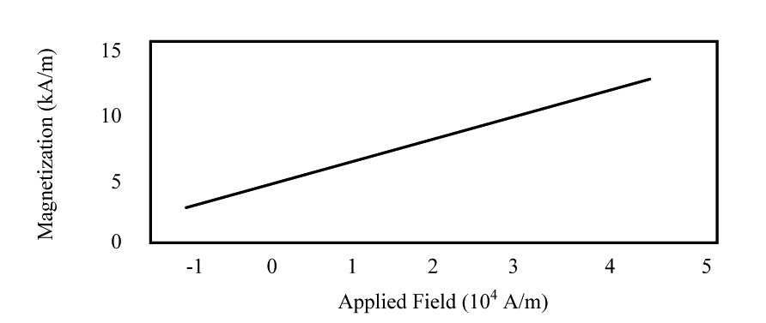

Fig. 1. Magnetization as a function of applied field.
Note how the caption is centered in the column.

II. HELPFUL HINTS
- A. Figures and Tables
Position figures and tables at the tops and bottoms of columns. Avoid placing them in the middle of columns. Large figures and tables may span across both columns. Figure captions should be centered below the figures; table captions should be centered above. Avoid placing figures and tables before their first mention in the text. Use the abbreviation “Fig. 1,” even at the beginning of a sentence.
Figure axis labels are often a source of confusion. Use words rather than symbols. For example, write “Magnetization,” or “Magnetization (M)” not just “M.” Put units in parentheses. Do not label axes only with units. In the example, write “Magnetization (A/m)” or “Magnetization (A ⋅ m1).” Do not label axes with a ratio of quantities and units. For example, write “Temperature (K),” not “Temperature/K.”
Multipliers can be especially confusing. Write “Magnetization (kA/m)” or “Magnetization (103 A/m).” Figure labels should be legible, about 10-point type.
- B. References
Number citations consecutively in square brackets [1]. Punctuation follows the bracket [2]. Refer simply to the reference number, as in [3]. Use “Ref. [3]” or Reference [3]” at the beginning of a sentence:“Reference [3] was the first …”
Number footnotes separately in superscripts. Place the actual footnote at the bottom of the column in which it was cited. Do not put footnotes in the reference list. Use letters for table footnotes (see Table I). IEEE Transactions no longer use a journal prefix before the volume number. For example, use “IEEE Trans. Magn., vol. 25,” not “vol. MAG-25.

Give all authors’ names; use “et al.” if there are six authors or more. Papers that have not been published, even if they have been submitted for publication, should be cited as “unpublished” [4]. Papers that have been accepted for publication should be cited as “in press” [5]. In a paper title, capitalize the first word and all other words except for conjunctions, prepositions less than seven letters, and prepositional phrases.
For papers published in translated journals, first give the English citation, then the original foreign-language citation [6].
- C. Abbreviations and Acronyms
Define abbreviations and acronyms the first time they are used in the text, even if they have been defined in the abstract. Abbreviations such as IEEE, SI, MKS, CGS, ac, dc, and rms do not have to be defined. Do not use abbreviations in the title unless they are unavoidable.
D. Equations
Number equations consecutively with equation numbers in parentheses flush with the right margin, as in (1). To make your equations more compact, you may use the solidus ( / ), the exp function, or appropriate exponents. Italicize Roman symbols for quantities and variables, but not Greek symbols. Use an en dash (–) rather than a hyphen for a minus sign. Use parentheses to avoid ambiguities in denominators. Punctuate equations with commas or periods when they are part of a sentence, as in

a + b = c. (1)

Symbols in your equation should be defined before the equation appears or immediately following. Use “(1),” not “Eq. (1)” or “equation (1),” except at the beginning of a sentence: “Equation (1) is …”
E. Other Recommendations
The Roman numerals used to number the section headings are optional. If you do use them, do not number ACKNOWLEDGMENT and REFERENCES, and begin Subheadings with letters. Use two spaces after periods (full stops). Hyphenate complex modifiers: “zero-field-cooled magnetization.” Avoid dangling participles, such as, “Using (1), the potential was calculated.” Write instead, “The potential was calculated using (1),” or “Using (1), we calculated the potential.”
Use a zero before decimal points: “0.25,” not “.25.” Use “cm3,” not “cc.” Do not mix complete spellings and abbreviations of units: “Wb/m2” or “webers per square meter,” not “webers/m2.” Spell units when they appear in text: “…a few henries,” not “…a few H.” If your native language is not English, try to get a native English-speaking colleague to proofread your paper. Do not add page numbers.

III. UNITS
Use either SI (MKS) or CGS as primary units. (SI units are encouraged.) English units may be used as secondary units (in parentheses). An exception would be the use of English units as identifiers in trade, such as “3.5-inch disk drive.”
Avoid combining SI and CGS units, such as current in amperes and magnetic field in oersteds. This often leads to confusion because equations do not balance dimensionally. If you must use mixed units, clearly state the units for each quantity that you use in an equation.
IV. SOME COMMON MISTAKES
The word “data” is plural, not singular. The subscript for the permeability of vacuum0 is zero, not a lowercase letter “o.” In American English, periods and commas are within quotation marks, like “this period.” A parenthetical statement at the end of a sentence is punctuated outside of the closing parenthesis (like this). (A parenthetical sentence is punctuated within the parentheses.) A graph within a graph is an “inset,” not an “insert.” The word alternatively is preferred to the word “alternately” (unless you mean something that alternates). Do not use the word “essentially” to mean “approximately” or “effectively.” Be aware of the different meanings of the homophones “affect” and “effect,” “complement” and “compliment,” “discreet” and “discrete,” “principal” and “principle.” Do not confuse “imply” and “infer.” The prefix “non” is not a word; it should be joined to the word it modifies, usually without a hyphen. There is no period after the “et” in the Latin abbreviation “et al.” The abbreviation “i.e.” means “that is,” and the abbreviation “e.g.” means “for example.” An excellent style manual for science writers is [7].
Acknowledgment
The preferred spelling of the word “acknowledgment” in America is without an “e” after the “g.” Try to avoid the stilted expression, “One of us (R. B. G.) thanks …” Instead, try “R.B.G. thanks …” Put sponsor acknowledgments in the unnumbered footnote on the first page.
References
[1] G. Eason, B. Noble, and I.N. Sneddon, “On certain integrals of Lipschitz-Hankel type involving products of Bessel functions,” Phil. Trans. Roy. Soc. London, vol. A247, pp. 529-551, April 1955.
[2] J. Clerk Maxwell, A Treatise on Electricity and Magnetism, 3rd ed., vol. 2. Oxford: Clarendon, 1892, pp.68-73.
[3] I.S. Jacobs and C.P. Bean, “Fine particles, thin films and exchange anisotropy,” in Magnetism, vol. III, G.T. Rado and H. Suhl, Eds. New York: Academic, 1963, pp. 271-350.
[4] K. Elissa, “Title of paper if known,” unpublished.
[5] R. Nicole, “Title of paper with only first word capitalized,” J. Name Stand. Abbrev., in press.
[6] Y. Yorozu, M. Hirano, K. Oka, and Y. Tagawa, “Electron spectroscopy studies on magneto-optical media and plastic substrate interface,” IEEE Transl. J. Magn. Japan, vol. 2, pp. 740-741, August 1987 [Digests 9th Annual Conf. Magnetics Japan, p. 301, 1982].
[7] M. Young, The Technical Writer’s Handbook. Mill Valley, CA: University Science, 1989.

