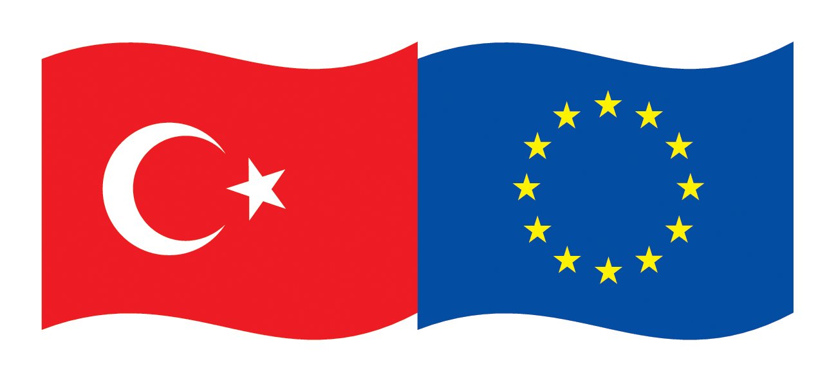 | EU Turkey Global Bridge Building  Initiative 2013  (EU-Turkey Business Connectivity on  Egyptian, Tunisian and Palestinian Markets)
- Are you looking for new and promising construction projects?
- Do you need partners who enhance your competitiveness?
- Are you interested in support for entering new markets?
- Do you like to save time & money by entering 3 markets at once?
If you say “yes” to one of these questions, please have a look to the
Tripartite Business Matchmaking Events sponsored by
European Union Delegation to Turkey
Ministry of economy Turkey
Union of Chambers and Commodity Exchanges of Turkey TOBB
The EU Delegation to Turkey has launched a new initiative titled EU-Turkey Global Business Bridges in partnership with the Ministry of Economy of Turkey and the Union of Chambers and Commodity Exchanges of Turkey (TOBB). The initiative aims at facilitating trade and investment partnerships between EU and Turkish companies in third countries by organizing three business matchmaking events in 2013 in Turkey, Egypt and Tunisia.
One of the Identified industries is construction(shopping malls and related businesses and services) in Egypt and the Palestine Territories (construction materials).
The matchmaking events will assist companies from EU to get new business opportunities, in a time where it is crucial to balance declining markets in the Euro Zone by new markets outside Europe. Turkish companies can expand their operations in the Southern Mediterranean Region in cooperation with their EU partners. Egypt and Tunisia are now looking for value proposals and reliable business partners to explore the opportunities after the political changes. The initiative offers businessmen first-hand information and contacts to potential partners, experience and market know-how in EU, Turkish, Egyptian, Palestinian and Tunisian markets.
Business opportunities for EU-Turkish co-operations exist in the following areas:
- Joint project development for construction projects in the target countries
- Trade and distribution of construction products and systems in the above mentioned industry
- Technical advice for clients, firms etc.
- Support of local enterprises through external know-how (planning, making, modernization, maintenance, quality assurance, product, controlling etc.)
- Financial participation in local enterprises, project financing solutions
- Cooperation in R & D
Experts assist participating companies in the search for potential counterparts, to meet them, to receive information on important subjects of the business cooperation, and to identify special solutions (technologically, financially) for projects in the above mentioned industry.
Insight views into new developments, markets and technologies, as well as acquisition support on concrete offers will be given by the project. Participating companies will have individual contacts with their potential partners, with representatives of legal authorities, with public and governmental organizations. The visit program is aimed to fit the individual demand of the participants.
Contact
EU: Mr. Claus D. Hagenhoff • ITM International Trade Marketing GmbH • PO Box 1320 • D-61364 Friedrichsdorf
Mobile: (+49-172) 670 10 70 • Fax: (+49 6172) 7572-99 • E-Mail: ch@itm-online.de • skype cdhagenhoff
Turkey: TOBB: Ms. Tuğçe Ersan / 0312-218-2436, Ms. Irmak Atalay / 0312-218-2438
E-Posta: gbbi@tobb.org.tr • http://businessbridges.tobb.org.tr • www.eu-turkeyglobalbusinessbridges.eu

This document is prepared by the DFC Group (Barcelona, Spain), financed under the European Union (EU) - funded project titled “Technical Assistance for Matchmaking Events under the Global Business Bridges Initiative”

Shopping Malls and related businesses and services in Egypt
Egypt and Turkey opened their first shopping malls in 1986 resp. 1988. Today there are close to 300 malls in Turkey while only around 30 in Egypt. 2000’s witnessed a boom in shopping malls in Egypt; several mall complexes opened including the largest and second largest shopping malls of the MENA region. The market is still highly unsaturated and is expected to grow hand in hand with the Egyptian middle class.
Shopping malls have wide-encompassing value chains that bring together SME’s in diverse fields such as waste management, security, IT and retail, and offer the early mover’s advantage in a rapidly growing market. Shopping malls have backward linkages to construction services, construction materials, safety and security services, electrical engineering, waste management and forward linkages to franchising and retail. The market for modern retail concept and shopping malls in Egypt is unsaturated, with most dense city (Cairo) having less gross leasable area per capita than several similar cities.
Most of the malls in Egypt are located around Cairo. Greater Cairo has 620,000 sqm of shopping mall area, with around 30 shopping malls (Istanbul: 4,1 million sqm area and 126 malls).
Most shopping malls are those that cater to the middle class, while three malls in Cairo (Beymen, First Mall and Galleria) cater to high income consumers. The trend of the past decade showed a rapid increase in the number of major shopping malls. City Stars was the largest shopping mall of the Middle East when it was opened in 2005, and has 150,000 sqm of gross leasable area. It is a part of a USD800 million project including retail, office, residential spaces and three hotels. Mall of Arabia opened in 2011 and surpassed City Stars as the largest mall of Egypt and second largest in the Middle East.
The number of shopping malls is growing fast: Mall of Egypt, 160,000 sqm mall expected to open in 2014. However, the market is unsaturated, with most dense city (Cairo) having less gross leasable area per capita than several similar cities.
Metropolitan Region | Population in millions | Gross Leasable Area in million m² (2011) | Gross Leasable Area per 1000 in m²
Cairo | 19,6 | 0,62 | 31,6
Istanbul | 13,2 | 4,1 | 310,6
Mumbai | 20,9 | 1,26 | 60,3
Beijing | 19,6 | 1,35 | 68,9
Jakarta | 28,3 | 3,87 | 136,7
Mexico City | 21,1 | 3,6 | 170,6
Increasing security concerns, as well as hot weather, and suburbanization due to high population density of the city is turning shopping centers into safe, accessible and attractive spaces for leisure activities (urban life factor).
The franchising market offers high potential for growth. There are only 45 operating franchises in Egypt, mostly food and clothing (compared to 1876 in Turkey). Fast-food chain sales reached 2,6 billion in 2010, showing 13% year to year increase. The Growing middle class expected to drive demand: Only 33 passenger cars per 1000 inhabitants as of 2009. (EU: 471, Turkey: 95, and Tunisia: 76).
The retail sales which increased by two-digits in each of the previous years have experienced a crease in 2011. Already in the course of the year 2012 there is a growth visible and 2013 will see again greater dynamics. Although this sector is still dominated by informal enterprises, it offers chances for the organized retail trade, which until now has conquered only small parts of the market volume. The radical changes in 2011 had considerable delays in the planned construction of shopping centers, a revival is apparent as of 2012. This just approaches the Non Food sector as well as foreign business firms and brands, too.
Building Materials in the Palestine Territories
Building materials constitute 27% of exports and is going to expand with the local construction boom in the Palestine Territories. EU countries whose exports are declining can take advantage of pairing with Turkish firms already active in the Palestinian Territories to benefit from the booming local demand.

Business Opportunities for EU and Turkish

Enterprises
There are many new construction projects including housing, shopping malls and related business services and building materials coming up in the target countries, which businesses out of Europe and Turkey can jointly explore. The objective of the matchmaking event in Turkey is therefore, to present and visualize the manifold opportunities for EU-Turkish business activities in Egypt and the Palestinian Territories. Topics such as joint project development, know-how and technology transfer, investment shall be discussed besides the issue of how to make business and how to operate in Egypt and the Palestinian Territories.

Turkish – EU Matchmaking Event
The event offers interested businesses from the mentioned industries the possibility to build up new and influential contacts in the target countries, to intensify existing contacts or to obtain a first-hand impression on the economic situation and opportunities. The matchmaking event is an active workshop for businesses, during which the participants receive information regarding ongoing plans and projects, have direct negotiations between enterprises and prepare first drafts of co-operations. Another topic will be the presentation of financial programs for projects or target countries. Workshops and trade fair visits will be organized, in addition to visits of companies and project sites. The participating businesses will be carefully prepared and advised by the assigned experts. Together with the project partners in Turkey and business associations, the experts will research suitable partners in the target countries, with which the business meet during the panels. The participating companies will be individually supported in terms of organization, laws and tax issues, and interpretation services where needed.

Fees: The participation is free of charge.

Travel: Flight to and from Antalya and hotel accommodation in Antalya can be booked individually or by local booking service in Turkey. Flight and hotel cost will be covered by the participants.

