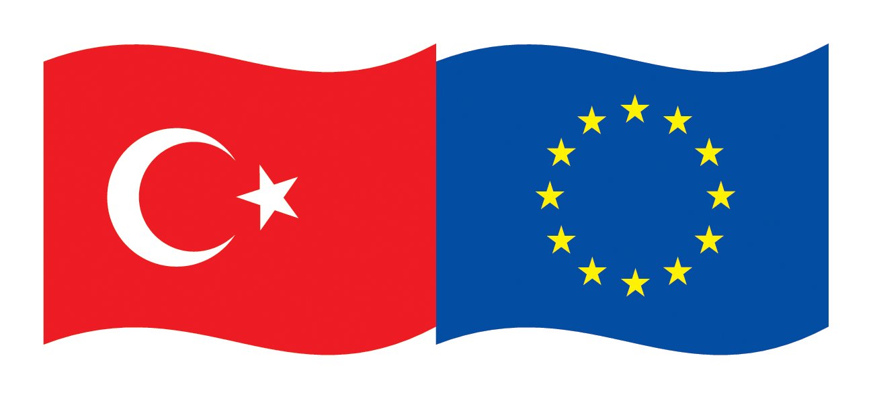 | EU Turkey Global Bridge Building  Initiative 2013  (EU-Turkey Business Connectivity on  Egyptian, Tunisian and Palestinian Markets)
- Are you looking for new and promising business opportunities
in the industries food & beverages, dairy and aquaculture, pharmacy?
- Do you need partners who enhance your competitiveness?
- Are you interested in support for entering new markets?
- Do you like to save time & money by entering 3 markets at once?
If you say “yes” to one of these questions, please have a look to the
Tripartite Business Matchmaking Events sponsored by
European Union Delegation to Turkey
Ministry of economy Turkey
Union of Chambers and Commodity Exchanges of Turkey TOBB
The EU Delegation to Turkey has launched a new initiative titled EU-Turkey Global Business Bridges in partnership with the Ministry of Economy of Turkey and the Union of Chambers and Commodity Exchanges of Turkey (TOBB). The initiative aims at facilitating trade and investment partnerships between EU and Turkish companies in third countries by organizing three business matchmaking events in 2013 in Turkey, Egypt and Tunisia.
Identified industries are food & beverages, dairy, aquaculture, pharmacy in Egypt, Tunisia, the Palestinian Territories.
The matchmaking events will assist companies from EU to get new business opportunities, in a time where it is crucial to balance declining markets in the Euro Zone by new markets outside Europe. Turkish companies can expand their operations in the Southern Mediterranean Region in cooperation with their EU partners. Egypt and Tunisia are now looking for value proposals and reliable business partners to explore the opportunities after the political changes. The initiative offers businessmen first-hand information and contacts to potential partners, experience and market know-how in EU, Turkish, Egyptian, Palestinian and Tunisian markets.
Business opportunities for EU-Turkish co-operations exist in the following areas:
- Joint development of projects related to processing industries in the target countries
- Trade and distribution of food and beverage products, systems and technology
- Technical advice for clients, firms etc.
- Support of local enterprises through external know-how (engineering, planning, making, packaging, modernization, maintenance, quality assurance, product, controlling, training etc.)
- Financial participation in local enterprises, project financing solutions
- Cooperation in R & D
Experts assist participating companies in the search for potential counterparts, to meet them, to receive information on important subjects of the business cooperation, and to identify special solutions (technologically, financially) for projects in the above mentioned industry.
Insight views into new developments, markets and technologies, as well as acquisition support on concrete offers will be given by the project. Participating companies will have individual contacts with their potential partners, with representatives of legal authorities, with public and governmental organizations. The visit program is aimed to fit the individual demand of the participants.
Contact
EU: Mr. Claus D. Hagenhoff • ITM International Trade Marketing GmbH • PO Box 1320 • D-61364 Friedrichsdorf
Mobile: (+49-172) 670 10 70 • Fax: (+49 6172) 7572-99 • E-Mail: ch@itm-online.de • skype cdhagenhoff
Turkey: TOBB: Ms. Tuğçe Ersan / 0312-218-2436, Ms. Irmak Atalay / 0312-218-2438
E-Posta: gbbi@tobb.org.tr • http://businessbridges.tobb.org.tr • www.eu-turkeyglobalbusinessbridges.eu
This document is prepared by the DFC Group (Barcelona, Spain), financed under the European Union (EU) - funded project titled “Technical Assistance for Matchmaking Events under the Global Business Bridges Initiative”

Egypt
Aquaculture in Egypt
Aquaculture is an emerging market in Egypt with predominantly freshwater intensive production, but with little or no processing. Marine aquaculture is largely missing, but is increasingly demanded in the EU and Egypt.
The total production of both fresh water and sea water fish was 919 thousand tons (2010 est.), with a domestic market size USD1,56 billion (2010 est.). The per-capita fish consumption is 15,9 kg/year, which is higher than Turkey (9kg/year) and close to EU average (22kg/year).
Aquaculture accounts to 65% of total seafood production, a sector of predominantly private firms (99%). Most aquaculture is concentrated in the freshwaters of the Nile Delta. Marine Aquaculture is relatively underdeveloped. Most widespread methods are semi-intensive farming in brackish water ponds or intensive farming in tanks (emerging). Marine fishing is comparatively weak due to underdeveloped seeding facilities and conflict with tourism. A long sea coast rich in natural feeds, is an untapped market
The sector sees a structural change. Informal businesses are being replaced by modern establishments. The domestic Market access is realised both through wholesalers and direct sales. Farmers can sell their goods in agricultural wholesale markets in every large city or make agreements with wholesalers.
The market is regulated by the General Authority for Fish Resources Development (GAFRD) and the National Aquaculture Legislation. R&D activity is mainly performed by government fisheries and the universities in Cairo, Ein Shams, Alexandria, Suez Canal, El Azhar, El Mansura, Tanta, Asuit, Zagazig and Upper Egypt.
Growth opportunities can be seen in the huge unmet demand: Egypt is a net importer of fish products with imports being 32 times of exports (2010, Source: UN Comtrade):
Commodity Description | Export Value | Import Value
Fish, frozen, excluding fillets | 254.317 | 255.456.343
Fish, prepared or preserved, nes | 145.395 | 104.937.539
Fish fillets, frozen | 137.574 | 33.389.634
Fish, fresh or chilled, excluding fillet | 11.601.109 | 982.931
Crustaceans and molluscs, prepared | 14.495 | 189.351
Total | 12.152.890 | 394.955.798
These figures explain the fast growth: The sector outperformed expectations by the Ministry of Agriculture (1 Million tons by 2017).
This already active value chain has over 300 hatcheries and 16 fish feed manufacturers which provide the necessary inputs for operating.
Market Access is given by preferential trade agreements for seafood with EU and GCC markets
There is a growing demand in the EU, which will reach from 22kg to 24kg per capita per year by 2030, with growth in some Eastern European countries reaching 50%. Marine fish accounting to 75% of consumption, besides the market trends of frozen fillets and ready-to-eat packages in the EU.
This sector has backward linkages to seed and feed production, and forward linkages to processing, freezing and packaging and cold chain storage. Turkish and EU firms can bring their know-how in marine aquaculture and fish processing to combine it with the market expertise and value chain know-how of Egyptian firms. In addition the EU firms can bring their know-how in sustainable and eco-friendly marine aquaculture.
Dairy market in Egypt
There are 3334 registered dairy firms active in Egypt, a number higher than all the Mediterranean companies except for Turkey. 95% of the firms in the sector are microenterprises employing fewer than 5 people. The country is a net importer of milk, chiefly from New Zealand, USA and EU. In 2011, net imports of milk were USD300 million.
Cheese and curd is the largest dairy export commodity, reaching USD482 million exports with a positive trade balance. Cheese is a rapidly growing export product: showing 68% CAGR (compound annual growth rate) between 2007 and 2011. Main export partners are Saudi Arabia, Iraq, Libya, and Yemen. Butter is a dairy product with a very small export market for Egypt. However Egypt’s butter imports reached a level of USD180 million in 2011. Chief import partners are New Zealand and USA.
Growth opportunities can be seen in the very large, young and expanding local market: A population of 82,5 million, with an annual growth rate of 1,96% and a median age of 24,3. However the local market is fragmented: 95% microenterprises point at opportunities in consolidation.
Good quality milk used for production of milk products such as cheese is sourced from expensive imported milk, with a price per net weight of 2,9USD/kg. Key problems in this area are difficulty of finding high quality raw milk and unhealthy production methods in some farms and the spoilage or deterioration of milk quality during transportation and storage.
Complementarities between Egyptian, Turkish and EU firms can improve the quality standards and introduce best practices in this value chain while taking part in the production of fast growing export products such as cheese. This sector has backward linkages to husbandry, production technology, health standards, and forward linkages to packaging equipment, packaging, cold storage and transport.

Tunisia
Agro food
The food and agricultural exports of Tunisia have totaled 1,2 billion USD per year. The three dominant groups of export are vegetable oils, vegetables and fruits (fresh and preserved), and seafood. Olive oil and dates are the two key products, accounting to 321 million USD and 200 million USD respectively. Tunisia is the world’s largest exporter of dates, with a market share of 28%. Tunisia is the 3rd largest exporter of olive oil and the 7th producer of olives and accounted for 4,2% of global production in 2010. Tomatoes, citrus fruits, potatoes, grapes, shrimps and pepper are the other major agricultural export items.
Exports tripled between 2002 and 2010, rising from 557 MTND to 1,651 MTND. Olive oil accounted for 27%, dates 17%, and seafood 12% of exports in the year 2010. ln 2010, Italy was Tunisia's biggest customer in food products (40% of all food exports), followed by Spain and Libya (34% for both countries).
Sectorial exports are predominantly not processed or lightly processed. In olive oil and wine, undiversified export markets, lack of branding and inconsistence in quality are obstacles for growth.
As there is relatively low product diversification and processing, export of processed or prepared products is small, accounting to 20 million USD. Exports of juices and non-alcoholic drinks account to 20 million USD while alcoholic beverages are around 17 million USD.
Agro-food imports reached 2,209 million TND in 2010 versus 1.322 million TND in 2006. Seed oils, sugar & derivatives and cereals & derivatives averaged 80% of imports in 2010. In 2010, Argentina and Brazil were the top two suppliers of food products in Tunisia (34% of imports) followed by the USA (13%) and France (7%).
Growth opportunities can be seen in the following areas:
Fruits and vegetables: Processing of fruits and vegetables into products such as preserves, jams, sweets and sweeteners both for local and export market
Pepper and cacao products are growing export items that can benefit from packaging and branding to achieve higher profit margins.
Olives and olive oil: Branding: Despite good quality, 42% of olive oil exports go to Italy, to be re-exported under Italian brands. Quality standards: European brands buy from intermediaries who cannot provide oils with consistent quality and taste. Direct production would enable quality control and eliminate intermediaries.
Non-alcoholic Beverages: juices of orange, grape and tomatoes.
Alcoholic Beverages: Export-oriented wine production.
European and Turkish businesses can combine their competences in food processing, quality standards and branding to realize the high potential of the sector. Tunisia cooperation potential with external partners can be seen in the strong development in neighboring countries (Algeria, Libya), in a technological park dedicated to the agro-food industry in Bizerta, and in technology development programs in cooperation with technical centers.
The process of moving up the market is currently in progress including a focus of a technical certification, technological innovation targeting priority products and upgrading collection circuits. The food industry has a large room for improvement given the potential for enhancement, upgrading and technological innovation for products. Certain niche markets can be developed, such as packaging of olive oil, packaging of semi-preserved fruits and vegetables, frozen food, ready and semi-cooked meals, semi-preserves, canned tomatoes, canned sardines, harissa, seafood (fresh, frozen), dried tomatoes, dried fruits and vegetables.
This sector has backward linkages to agriculture, food processing machinery, and forward linkages to derivative products such as cosmetics, culinary tourism, packaging, and design. Transport and logistics is also an integral determinant of the sector’s overall competitiveness.

The Palestinian Territories

Looking to the food and beverages market in the Palestinian Territories, the growing local demand can be better leveraged particularly in the dairy products, cereals and processed vegetables & fruits. The caveat of this sector is the relatively small domestic market, logistical constraints and possible export constraints that may be imposed by Israel in competing sectors. The products in this sector would need to have high value added per weight, export oriented and not competing with Israeli goods in the export markets. Agricultural products can be exported quota free to EU. Exported are fruits, dates, cut flowers, herbs, vegetable, tomatoes, olives, and tropical fruits.
Pharmaceutical products and the medicine sector is advanced and promising, The country tries to buy licenses to produce generic medicine. An agreement between EU and Israel was recently signed to facilitate test permits, which can include the Palestinian territories.

Business Opportunities for EU and Turkish Enterprises

Food & beverages, dairy and aquaculture show many new business opportunities in the target countries, which businesses out of Europe and Turkey can jointly explore.

The objective of the matchmaking event in Turkey is therefore, to present and visualize the manifold opportunities for EU-Turkish business activities in Egypt, Tunisia, and the Palestinian Territories. Topics such as joint project development, know-how and technology transfer, investment shall be discussed besides the issue of how to make business and how to operate in Egypt, Tunisia, and the Palestinian Territories.

Turkish – EU Matchmaking Event

The event offers interested businesses from the mentioned industries the possibility to build up new and influential contacts in the target countries, to intensify existing contacts or to obtain a first-hand impression on the economic situation and opportunities.
The matchmaking event is an active workshop for businesses, during which the participants receive information regarding ongoing plans and projects, have direct negotiations between enterprises and prepare first drafts of co-operations.
Another topic will be the presentation of financial programs for projects or target countries. Workshops and trade fair visits will be organized in order to visit companies and relevant sites. The participating businesses will be carefully prepared and advised by the assigned experts. Together with the project partners in Turkey and business associations, the experts will research suitable partners, with which the business meet during the panels. The participating companies will be individually supported in terms of organization, laws and tax issues, and interpretation services where needed.

Fees: The participation is free of charge.

Travel: Flight to and from Antalya and hotel accommodation in Antalya can be booked individually or by local booking service in Turkey. Flight and hotel cost will be covered by the participants.

