
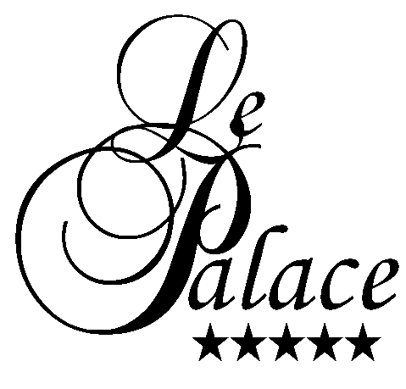

Room Reservation Form

“ Matchmaking Event “ under GBBI”

LE PALACE Hotel

11th & 12th of June 2013

First Name:______________________ ■ Last Name:________________________

Email: ______________________________________________________________

Check in date:____________________ ■ Check out : ________________________

Type of room : ___________________ ■ No. of rooms : ______________________

Type of room :
Single room : 84 EUR
Double room : 115 EUR
Above rates are based on bed & buffet breakfast per room per night, inclusive services & taxes charge

Payment:

Credit card number / ………………………………………

Validity date /……………………………………………...

Expiry date /………………………………………………

Authorization /………………………………………………

Payment policy:
Full payment must be paid by credit card with authorization to guarantee booking.
Time limit for reservation maximum by 06.06.2013

Cancellation & no show policy:
- Time Limit for reservation : 07.06.2013
- In case of No -show will be charged full stay cancellation fees
- Any cancellation after 07.06. 2013 will charge full stay cancellation fees.

Amel BOU SAID

Director of Sales
LE PALACE Hotel – Gammarth
Tel : 216 71 912 000
Fax : 216 71 911 442
Email : sales@lepalace.tn

