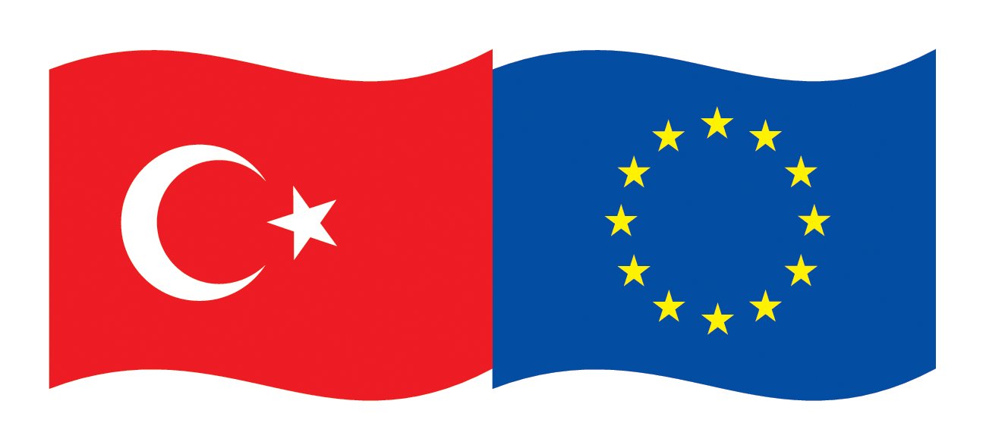 | EU Turkey Global Bridge Building  Initiative 2013  (EU-Turkey Business Connectivity on  Egyptian, Tunisian and Palestinian Markets)
- Are you looking for new and promising business opportunities?
- Do you need partners who enhance your competitiveness?
- Are you interested in support for entering new markets?
- Do you like to save time & money by exploring 3 markets at once?
If you say “yes” to one of these questions, please have a look to the
Tripartite Business Matchmaking Events sponsored by
European Union Delegation to Turkey
Ministry of economy Turkey
Union of Chambers and Commodity Exchanges of Turkey TOBB
The EU Delegation to Turkey has launched a new initiative titled EU-Turkey Global Business Bridges in partnership with the Ministry of Economy of Turkey and the Union of Chambers and Commodity Exchanges of Turkey (TOBB). The initiative aims at facilitating trade and investment partnerships between EU and Turkish companies in third countries by organizing three business matchmaking events in 2013 in Turkey, Egypt and Tunisia.
Two of the identified industries are production of ready-made garments and plastics in the Palestine Territories.
The matchmaking events will assist companies from EU to get new business opportunities, in a time where it is crucial to balance declining markets in the Euro Zone by new markets outside Europe. Turkish companies can expand their operations in the Southern Mediterranean Region in cooperation with their EU partners. Egypt and Tunisia are now looking for value proposals and reliable business partners to explore the opportunities after the political changes. The initiative offers businessmen first-hand information and contacts to potential partners, experience and market know-how in EU, Turkish, Egyptian, Palestinian and Tunisian markets.
Business opportunities for EU-Turkish co-operations exist in the following areas:
- Joint production projects in the target countries
- Trade and distribution of products, systems and technology
- Technical advice for clients, firms etc.
- Support of local enterprises through external know-how (engineering, planning, making, packaging, modernization, maintenance, quality assurance, product, controlling, training etc.)
- Financial participation in local enterprises, project financing solutions
- Cooperation in R & D
Experts assist participating companies in the search for potential counterparts, to meet them, to receive information on important subjects of the business cooperation, and to identify special solutions (technologically, financially) for projects in the above mentioned industry.
Insight views into new developments, markets and technologies, as well as acquisition support on concrete offers will be given by the project. Participating companies will have individual contacts with their potential partners, with representatives of legal authorities, with public and governmental organizations. The visit program is aimed to fit the individual demand of the participants.

Contact
EU: Mr. Claus D. Hagenhoff • ITM International Trade Marketing GmbH • PO Box 1320 • D-61364 Friedrichsdorf
Mobile: (+49-172) 670 10 70 • Fax: (+49 6172) 7572-99 • E-Mail: ch@itm-online.de • skype cdhagenhoff
Turkey: TOBB: Ms. Tuğçe Ersan / 0312-218-2436, Ms. Irmak Atalay / 0312-218-2438
E-Posta: gbbi@tobb.org.tr • http://businessbridges.tobb.org.tr • www.eu-turkeyglobalbusinessbridges.eu

This document is prepared by the DFC Group (Barcelona, Spain), financed under the European Union (EU) - funded project titled “Technical Assistance for Matchmaking Events under the Global Business Bridges Initiative”

The Palestinian Territories

The potential business sectors of the Palestinian Territories need to consider the political situation of the country as a territory occupied by the State of Israel. So it is the question what are sectors which offer clear opportunities for external partners. Those sectors will have to consider not only the demand in the domestic markets but also those in the markets of Israel as there is no customs and basically a very easy access of products made in the Palestinian Territories to Israel.

TEPAV has indicated that 85% of the country’s exports were addressed to Israel whereas only 15% of them were addressed to the other countries. Similarly, Israel has a 73% share in the imports of the Palestinian Territories. From this figures it is clear that one might find more economic potential if one looks closer to the import statistics of Israel: The Israel market plus the markets in those countries with which Israel has special relations might offer additional opportunities for items which are produced in the Palestinian Territories by local and/or new foreign investors. Those sectors which are of need in the Palestinian Territories itself, in Israel plus in those countries with which Israel has special relations, and in the neighboring country Jordan where the majority of the population is Palestinian, are potential areas for joint business undertakings by Turkish and EU companies in the Palestinian Territories:

a. ICT related businesses: An educated workforce and competitive labor costs, independence from logistical constraints, and strong competitiveness in web and applications development makes the Palestinian Territories an attractive location for the European businesses that aim at expanding into Arabic-speaking countries, or “Arabize” their software.

b. Food and beverages: The growing local demand can be better leveraged particularly in the dairy products, cereals and processed vegetables & fruits. The caveat of this sector is the relatively small domestic market, logistical constraints and possible export constraints. The products in this sector would need to have high value added per weight and export oriented.

c. Building materials: This sector constitutes 27% of exports and is going to expand with the local construction boom. EU countries whose exports are declining can take advantage of pairing with Turkish firms already active in the Palestinian Territories to benefit from the booming local demand.

d. Textiles and garments: The Palestinian Territories has a relatively less diversified export market for this sector. Footwear is the major export item in this sector, and Turkish and EU firms can diversify the export destinations and increase the value added in production. The key advantage of the Palestinian Territories is the direct access to the US markets via Israel-USA FTA, and the indirect access to USA via Egypt and Jordan through the Qualifying Industrial Zones (QIZ) Agreement.

e. Plastics and disposables production in the Palestinian Territories for the Israel market can be highlighted as an option of articles which then are marketed in Israel and those countries with which Israel has a special relations (like the USA). Simple products which can be easily manufactured, have definitely a market in Israel and will secure employment, salaries, and will have positive spill over effects to others in the Palestinian Territories.

Besides that, the Turkish Economic Policy Research Foundation (TEPAV) has co-operated since a number of years to assist the Palestinian Territories in organizing the Jenin Industrial Park as a business opportunity for foreign investments.

Business Opportunities for EU and Turkish

Enterprises

There are many new business opportunities, which businesses out of Europe and Turkey can jointly explore. The objective of the matchmaking event in Turkey is therefore, to present and visualize the manifold opportunities for EU-Turkish business activities in Egypt, Tunisia, and the Palestinian Territories. Topics such as joint project development, know-how and technology transfer, investment shall be discussed besides the issue of how to make business and how to operate in Egypt, Tunisia, and the Palestinian Territories.

Turkish – EU Matchmaking Event

The event offers interested businesses from the mentioned industries the possibility to build up new and influential contacts in the target countries, to intensify existing contacts or to obtain a first-hand impression on the economic situation and opportunities. The matchmaking event is an active workshop for businesses, during which the participants receive information regarding ongoing plans and projects, have direct negotiations between enterprises and prepare first drafts of co-operations. Another topic will be the presentation of financial programs for projects or target countries. Workshops and trade fair visits will be organized, in addition to visits of companies and project sites. The participating businesses will be carefully prepared and advised by the assigned experts. Together with the project partners in Turkey and business associations, the experts will research suitable partners in the target countries, with which the business meet during the panels. The participating companies will be individually supported in terms of organization, laws and tax issues, and interpretation services where needed.

Fees: The participation is free of charge.

Travel: Flight to and from Antalya and hotel accommodation in Antalya can be booked individually or by local booking service in Turkey. Flight and hotel cost will be covered by the participants.

